
European Ceramic Society

Russian Academy of Sciences

Russian Foundation for Basic Research
Institute of Silicate Chemistry RAS

INFORMATION AND Structure
IN the Nanoworld

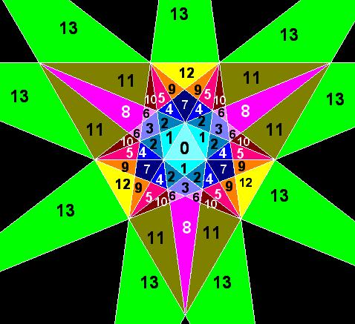

Icosahedron stellation diagram center

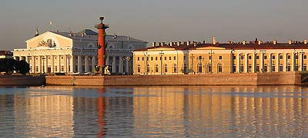

1-3 July 2009
Saint-Petersburg, Russia

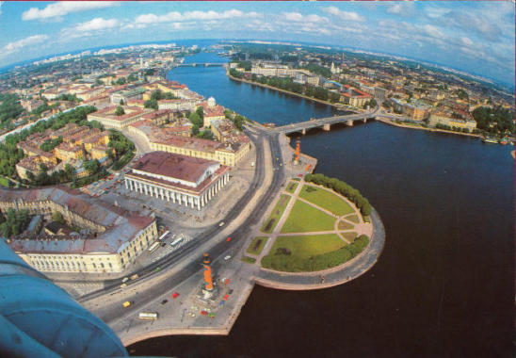

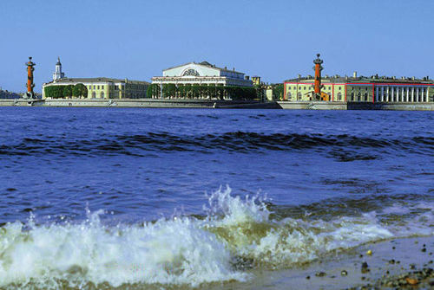

Place of conference:
Institute of Silicate Chemistry of the Russian Academy of Sciences

Organizing committee

Honorary Chairmen V.Ya. Shevchenko, Russia
A.L. Mackay, UK

Chairmen B.F. Myasoedov, Russia
H.D. Chechenov, Russia

International Advisory Board

S. Andersson, Sweden J. Klinowski, UK
R. Catlow, UK S. Lidin, Sweden
W. Depmeier, Germany R. Mosseri, France
A. Dress, China M. Nespolo, France
G. Ferraris, Italy M. O'Keeffe, USA
I. Hargittai, Hungary J.-F. Sadoc, France
S. Hovmöller, Sweden M. Senechal, USA
S. Hyde, Australia D. Proserpio, Italy
M. Kléman, France

National Advisory Board

V.A. Blatov, Samara S.V. Krivovichev, St. Petersburg
V.E. Dmitrienko, Moscow I.G. Tananaev, Moscow
G.D. Ilyushin, Moscow B.B. Venkov, St. Petersburg
M.V. Kovalchuk, Moscow V.S. Urusov, Moscow

Local Organizing Committee

V.V. Ivashkin L.P. Mezentseva
O.Yu. Golubeva I.Yu. Kruchinina
N.Z. Shaydullin A.E. Lapshin

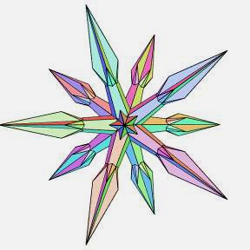
Administrative Group

E. Tugova,
T. Maslennikova,
S. Yalymov

Stellation of strombic
hexecontahedron

gENERAL information
Scope of the Conference
The Conference is intended to provide an arena for discussion of one of the most important part of the modern nanotechnology-related science – information conservation and processing in the Nanoworld, a world of beautiful and amazing structures and phenomena.
The Conference will gather scientists from different fields and experiences that will favor cross-discipline communication and fruitful discussion.

Main Topics
Nanoworld
• Definition and Properties
• Coherency
• The concept of inorganic gene
Structure and geometry: application of mathematical techniques to the description and interpretation of nanoscale structures
• Non-crystallographic symmetries
• Non-Euclidean geometries
• Exploration of high-dimensional space
• Sphere packings
• Share configuration
• Spherical codes and designs
• Nets and tilings
• Minimal surfaces
Information transfer in the Nanoworld and models of self-assamly
• Emergence of new configuration
• Spontaneous self-organization
• Cellular automata
• Shape grammar
• Languages of desigh
• Complexity
New discoveries in nanochemistry: summary of recent results
• Nanoclusters
• Nanocages
• Building blocks
• Nanoporous frameworks
• Templates
• Structural heirarchies
• Novel nanostructures
• Architecture of metal-organic frameworks
• Layers

Computer modeling in nanochemistry
• Methods for modeling nanosystems
• Program packages for analyzing structures of nanoparticles and crystals
• Application of computer methods to the synthesis of new materials
Information and structures in biological nanostructures
• Structure of biological nanoparticles
• Information transfer in biological nanostructures

Presentation Formats
The Conference will include plenary lectures (Pl) and posters (P).
Language
The official language of the Conference is English.
Conference Organizers
The Conference “INFORMATION AND StructureIN the Nanoworld” is organized by the Institute of Silicate Chemistry of the Russian Academy of Sciences, Russian Foundation for Basic Research and promoted by the European Ceramic Society.
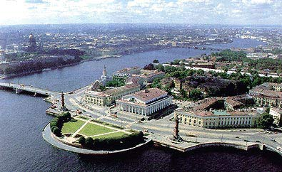

Sessions Timetable
TIME | Tuesday JUNE 30 | Wednesday  JULY 01 | Thursday  JULY 02 | Friday  JULY 03
8.30-9.00 |  | REGISTRATION  Poster mounting*
9.00-9.20 |  | CONFERENCE OPENING
9.20-10.00 |  | PL-01 | PL-07 | PL-13
10.00-10.40 |  | PL-02 | PL-08 | PL-14
10.40-11.10 |  | COFFEE BREAK | COFFEE BREAK | COFFEE BREAK
11.10-11.50 |  | PL-03 | PL-09 | PL-15
11.50-12.30 |  | Laboratory’s attendance | Laboratory’s attendance | Laboratory’s attendance
12.30-14.00 |  | DINNER | DINNER | DINNER
14.00-14.40 | REGISTRATION | PL-04 | PL-10 | PL-16
14.40-15.20 | REGISTRATION | PL-05 | PL-11 | PL-17
15.20-15.50 | REGISTRATION | COFFEE BREAK | COFFEE BREAK | COFFEE BREAK
15.50-16.30 | REGISTRATION | PL-06 | PL-12 | PL-18
16.30-17.30 | REGISTRATION | Discussion | Discussion | Discussion,  poster dismounting
 |  |  |  | CONFERENCE CLOSURE
18.00 | REGISTRATION | GET TOGETHER PARTY | BANQUET | EXCURSION
INFORMATION AND Structure IN the Nanoworld
Topical Meeting of the European Ceramic Society
1-3 July, 2009, Saint-Petersburg, Russia

* POSTERS: 1-3 July, 2009; 9-30 – 18-00

Provisional program
INFORMATION AND StructureIN the Nanoworld
Topical Meeting of the European Ceramic Society
1-3 July, 2009, Saint-Petersburg, Russia

CONFERENCE OPENING
opening addresses, which will be presented by
A.L. Mackay, UK
B.F. Myasoedov, Russia
V.Ya. Shevchenko, Russia
Plenary Lectures
PL-01 | Dense lattices and energy minimization.  B.B. Venkov  Institute of Silicate Chemistry of RAS, Saint-Petersburg, Russia
PL-02 | On peculiar aspects of geometrical frustration with cylindrical geometries or confinement.  R. Mosseri  Laboratoire de Physique Théorique de la Matière Condensée, Université Paris, France
PL-03 | Parallelohedra: Old Problems and New Results.  N.P. Dolbilin  Steklov Mathematical Institute of RAS, Moscow, Russia
PL-04 | Continuous Deformation Extending over Three Sphere Packing Structures—Simple, Body-centred and Face-centred Cubic Structures.  Y. Teshima¹ and T. Matsumoto²  ¹National Institute of Advanced Industrial Science and Technology (AIST),  1-2 Namiki, Tsukuba, Ibaraki 305-8564, Japan  ²Kanazawa University (Prof. Emeritus), Japan
PL-05 | Computer analysis of intermetallic compounds: microcluster approach.  V.A. Blatov  Samara State University, Samara, Russia
PL-06 | What do we know about non-crystallographic nets?  J.G. Eon  Institute of Chemistry, Federal University of Rio de Janeiro, Av. Athos  da Silveira Ramos, 149 Bloco A, 21941-909 Cidade Universitaria, Rio de  Janeiro, Brazil
PL-07 | Combinatorial Pattern Discovery in Biosequences  A. Apostolico  Georgia Institute of Technology & University of Padova, Italy
PL-08 | Finite automata and local theorem as applied to the lovozerite-type structures.  S.V. Krivovichev  Saint Petersburg State University, Institute of Silicate Chemistryof RAS, Saint-Petersburg, Russia
PL-09 | Cluster self-organization of crystal-forming systems: suprapolyhedral nanoclusters-precursors and mechanism of self-assembling icosahedral structures MgCu₂ (cF24), ZrZn₂₂ (cF184) and Mg₂Al₃ (cF1168).  G.D. Ilyushin  Institute of Crystallography of RAS, Moscow, Russia
PL-10 | Understanding Polymorphism in the bulk and in nanomaterials: topological concepts and numerical approaches.  S. Leoni  Max-Planck-Institute for Chemical Physics of Solids, Dresden, Germany
PL-11 | Nanomaterials and nanotechnologies in nuclear industry, radiochemistry and radioecology  I.G. Tananaev¹, S.I. Rovny²  ¹Institute of Physical Chemistry and Electrochemistry of RAS, Moscow, Russia  ² PO «Mayak», Ozersk, Russia
PL-12 | Self-organization processes in tetraethoxysilane-derived sol-gel systems under influence of inorganic and organic modifying substances.  O.A. Shilova  Institute of Silicate Chemistry RAS, Saint-Petersburg, Russia
PL-13 | Novel Structural Trees and Their Application to Protein Folding and Modeling.  A.V. Efimov  Institute of Protein Research of RAS, Pushchino, Russia
PL-14 | Charge Transfer in DNA and Nanobioelectronics.  V.D. Lakhno  Institute of Mathematical Problems of Biology, Pushchino, Russia
PL-15 | Toponome imaging microscopy MELC/TIS in cell biology and translational medicine.  W. Schubert  Molecular Pattern Recognition Research Group, Medical Faculty, Otto-von-Guericke-University Magdeburg, Germany, CAS-MPG Partner Institute for Computational Biology, Shanghai, China
PL-16 | Pulling as a determinative factor in formation of the heterophasic structure of multidomain proteins of immunoglobulin superfamily.  A.A. Vazina  Institute of theoretical and Experimental Biophysics of RAS  Russian Research Center “Kurchatov Institute”, Pushchino, Russia
PL-17 | Dynamical Self-Organized Fullerite Structures.  L.A. Bityuzkaya  Voronezh State University, Voronezh, Russia
PL-18 | Thermal rising of symmetry in nano- and macroworlds.  S.K. Filatov  Saint Petersburg State University, Saint-Petersburg, Russia

Posters

P-01 | Thermal behavior of NH₄B₅O₈  J.E. Anderson ¹, R.S. Bubnova ¹, M.G. Krzhizhanovskaya ², S.К. Filatov²  ¹Institute of Silicate Chem. RAS, Spb, Russia  ²Saint-Petersburg State University
P-02 | Size Effects In The Process Of Gold And Silver Nanoparticles Formation.  G.P. Aleksandrova, L.P. Feoktistova, L.A. Grishchenko, A.N. Sapozhnikov,  B.G. Sukhov, B.A. Trofimov  A.E. Favorsky Irkutsk Institute of Chemistry SB RAS,  A.P. Vinogradov Institute of Geochemistry SB RAS, Irkutsk, Russia
P-03 | Clusters of Mn ions in solid solution La_{0.67}Sr_{0.33}MnO₃-LaAlO₃.  R.R. Andronenko, S.I. Andronenko  Institute of Silicate Chemistry of RAS, Saint-Petersburg, Russia
P-04 | Synthesis and Investigation of Nanostructured Ceramics in the System ZrO₂–Y₂O₃–Al₂O₃. Modeling of Oxygen Ion Transport Processes.  M.Yu. Arsentyev, L.V. Morozova, T.I. Panova, P.A. Tikhonov  Institute of Silicate Chemistry of RAS, Saint-Petersburg, Russia
P-05 | Chemical synthesis of titanium dioxide nanoparticles of various modifications.  L.P. Efimenko, V.G. Baryshnikov, K.E. Pugachev  Institute of Silicate Chemistry of RAS, Saint-Petersburg, Russia
P-06 | The complex investigation of dental and salivary calculi: mechanism of their formation.  L.V. Belskaya, O.A. Golovanova  Department of Chemistry, Omsk State University, Omsk, Russia
P-07 | Self-assembly of fundamental building blocks (FBB) in borate structures as a result of atomic thermal vibrations and FBB.  R.S. Bubnova¹, S.K. Filatov²  ¹Institute of Silicate Chemistry of RAS, Saint-Petersburg, Russia  ²Dept. of Crystallography, St.-Petersburg State University, Saint-Petersburg, Russia
P-08 | Thermal expansion and phase transition in Ca₈[Al₁₂O₂₄](WO₄)₂ due to WO₄ tetrahedra rotation.  S.K. Filatov¹, S.N. Wolkov¹, R.S. Bubnova², W. Depmeier³, M.G. Krhizhanovskaya¹, V.L. Ugolkov²  ¹Saint Petersburg State University, Saint-Petersburg, Russia;  ²Institute of Silicate Chemistry of RAS, Saint-Petersburg, Russia;  ³Kiel University, Kiel, Germany
P-09 | Formation of nanocrystal phases in amorphous TiO₂ films.  L.P. Efimenko¹, A.E. Komlev², A.E. Lapshin¹, O.V. Magdysyuk¹, V.L. Ugolkov¹, V.I. Shapovalov², I.V. Smirnova¹  ¹Institute of Silicate Chemistry of RAS, Saint-Petersburg, Russia  ²St. Petersburg State Electrotechnical University "LETI", Saint-Petersburg, Russia
P-10 | Oxidation of Fe, Co, W – nanoparticles during continuous heating.  N.O. Gonchukova, S.L. Ratushnyak  Institute of Silicate Chemistry of RAS, Saint-Petersburg, Russia
P-11 | Self-Organization of Alkali Silicate-derived Porous Structures under Conditions of Cryogenic Sublimation  S.V. Hashkovski, T.V. Khamova, O.A. Shilova  Institute of Silicate Chemistry of RAS, Saint-Petersburg, Russia
P-12 | Si₃N₄ and SiC Whiskers.  Yu.F. Kargin, S.N. Ivicheva, A.S. Lysenkov, N.A. Ovsyannikov, G.Yu. Yurkov  A.A. Baikov Institute of Metallurgy and Materials Science of RAS, Moscow, Russia
P-13 | Structure process and aggregation in tetraethoxysilane-derived sol-gel systems under influence of inorganic substances.  T.V. Khamova, T.G. Movchan, E.V. Golikova, O.A. Shilova  Institute of Silicate Chemistry of RAS, Saint-Petersburg, Russia
P-14 | The introduction of lanthanide nanoclusters into silica matrix.  N.N. Khimich, A.V. Zdravkov, G.M. Berdichevskiy, V.V. Golubkov  Institute of Silicate Chemistry of RAS, Saint-Petersburg, Russia
P-15 | Activated sintering tungsten and W-HfC composite.  O.G. Klimova¹, O.V. Tolochko¹, S.S. Ordanian², D.-I. Cheong³, Youngmoo Kim³  ¹Saint-Petersburg State Polytechnical University, Saint-Petersburg, Russia  ²Saint-Petersburg State Technological Institute, Saint-Petersburg, Russia  ³Chungnam National University, Daejeon, South Korea
P-16 | Becoming random close packing.  V.V. Klyucharev  Institute of problems of chemical physics of RAS, Chernogolovka, Russia
P-17 | Nanotechnology for Encapsulating Titanium Boride and Zirconium Boride upon Formation of Heat-Resistant Composites.  I.B. Ban’kovskaya, I.G. Polyakova, D.V. Kolovertnov  Institute of Silicate Chemistry of RAS, Saint-Petersburg, Russia
P-18 | FRAKS and DICSI Stations on the Siberian and Moscow SR for Studying Biological Nanostructures  V.N. Korneev¹, B.P. Tolochko², A.V. Zabelin³ , A.A. Vazina⁴  ¹Institute of Cell Biophysics, RAS, Pushchino, Russia  ²Budker Institute of Nuclear Physics of SB, RAS, Novosibirsk, Russia  ³FSI, RRC “Kurchatov Institute”, Moscow, Russia  ⁴Institute of Theoretical and Experimental Biophysics, RAS, Pushchino, Russia
P-19 | Destructure effect implantation in silicon research by electron X-ray photoemission.  S.A. Kukushkin  Ryazan State University, Ryazan ,Russia
P-20 | X-ray fluorescence and small-angle diffraction study of changes of nanostructural organization of tumor transformed epithelial tissues.  A.A. Vazina^{1,4}, N.F. Lanina¹, A.A. Vasilieva¹, V.N. Korneev²,  T.A. Kupriyanova³, O.V. Nayda⁴, A.V. Zabelin⁴, V.P. Letyagin⁵, E.I. Maevsky¹  ¹Institute of Theoretical and Experimental Biophysics of RAS, Pushchino, Russia  ²Institute of Cell Biophysics of RAS, Pushchino, Russia  ³Institute of General and Inorganic Chemistry of RAS, Moscow, Russia  ⁴Russian Research Center “Kurchatov Institute”, Moscow, Russia  ⁵Blokhin Science Center of Oncology, Department of Breast Tumor, Moscow, Russia
P-21 | Structure of the oxo-centered trimetallic Co(III), [C₃₀H₆₀O₁₆Co₃]⁺.NO₃⁻·3H₂O.  A.E. Lapshin, O.V. Magdysyuk  Institute of Silicate Chemistry of RAS, Saint-Petersburg, Russia
P-22 | Structure of the biological active binuclear complex of palladium in compound of [Pd₂(C₁₂H₈N₂)₂(C₂H₇NCl)₂]₂^{8+·}8NO₃⁻·2H₂O.  A.E. Lapshin, O.V. Magdysyuk  Institute of Silicate Chemistry of RAS, Saint-Petersburg, Russia
P-23 | Molecular characteristics of cellulose pelargonate macromolecules in solutions.  N.V. Tsvetkov¹, V.О.Ivanova¹, N.G. Matveeva¹, E.V. Lebedeva¹, A.N. Podsevalnikova¹, A.K. Khripunov²  ¹Faculty of Physics, St. Petersburg State University, Saint-Petersburg, Petrodvorets, Russia  ²Institute of Macromolecular Compounds of RAS, Saint-Petersburg, Russia
P-24 | Synthesis and molecular properties of polymerized micelles in dilute solutions.  N. V. Tsvetkov¹, L. N. Andreeva², S. V. Bushin², M.A. Bezrukova², I.A. Strelina², V. O. Ivanova², E.V. Lebedeva¹, N.G. Matveeva¹, I.M. Zorin³, I.A. Makarov³, and A. Yu. Bilibin³  ¹Faculty of Physics, St. Petersburg State University, Petrodvorets, Russia  ²Institute of Macromolecular Compounds of RAS, Saint-Petersburg, Russia  ³Faculty of Chemistry, St. Petersburg State University, Petrodvorets, Russia
P-25 | Hydrodynamic and conformational properties of pelargonates cellulose molecules.  M.A. Bezrukova¹, E.P. Astapenko¹, E.V. Lebedeva², A.K. Khripunov¹, S.V. Bushin¹  ¹Institute of Macromolecular compounds of RAS, Saint-Petersburg, Russia  ²Saint-Petersburg state university, faculty of physics, Petrodvorets, Russia
P-26 | Nanostructured properties of apatite of a bone fabric of the person.  S.A. Lemesheva¹, O.A. Golovanova¹, S.V. Turenkov²  ¹Omsk State University, department of chemistry, Omsk, Russia  ²Clinical Medical-Surgical Center, Omsk, Russia
P-27 | Dimensions and properties of polyaniline-polyelectrolyte nanoparticles in solutions.  G.E. Polushina, A.A. Lezov, A.V. Lezov  Saint-Petersburg University, Physical Faculty, Petrodvorets, Russia
P-28 | On local criterion for crystallographic tilings of Euclidean plane.  E.S. Marinin  Moscow State University, Moscow, Russia
P-29 | Standing x-ray wave spectroscopy of surface atomic layers.  E.N. Moos, I.A. Seltzer  Ryazan State University, Ryazan, Russia
P-30 | Nanostructure Modificated Contact Surface.  S.M. Karabanov¹, R.M. Maysels¹, E.N. Moos ², V.A. Sablin¹, I.A. Seltzer¹  ¹RSMKP plant, Ryazan, Russia  ²Ryazan State University, Ryazan, Russia,
P-31 | Stability and the size of detonation diamond nanoclusters  in tetraetoxysilane-derived sol-gel systems.  N.I. Nicolajchuk, E.V. Golikova  Institute of Silicate Chemistry of RAS, Saint-Petersburg, Russia
P-32 | Wavelet analysis of filbrillar molecular biosystems.  R.V. Polozov¹, V.S. Sivozhelezov²  ¹Institute of Theoretical and Experimental Biophysics of RAS, Pushchino, Russia  ²Institute of Cell Biophysics of RAS, Pushchino, Russia
P-33 | Influence of polymers modification by nano-dispersed ceramic nano-particles on the nanocomposites properties.  V. Polyboiarov, T. Belkova, A. Goncharov  ISSC SB RAS, Novosibirsk, ZAO Uralplastic, Ekaterinburg
P-34 | Structural self-organization on nanocrystal – monocrystal interfaces.  V.M. Ievlev¹, A.S. Prizhimov¹, A.V. Evteev², A.T. Kosilov²  ¹Voronezh State University, Voronezh, Russia  ²Voronezh State Technical University, Voronezh, Russia
P-35 | Synthesis and investigation of nano-sized layers on the basis of  TbO_{x} and (TbO_{x})_{0.5}∙(YO_{1.5})_{0.5} solid solution.  P.V. Rastegaev, P.A. Tikhonov, M.V. Kalinina  Institute of Silicate Chemistry of RAS, Saint-Petersburg, Russia
P-36 | Interactions of nanoscale crystalline components in hybrid inorganic-organic biomaterials of calcium phosphates and acetobacter xylinum cellulose: experiment and computer modeling.  D.P. Romanov ¹, Ju.G. Baklagina ², N.V. Lukasheva ², A.K. Khripunov ²,  V.V. Klechkovskaja ³, N.A. Arkharova ³, D.A. Tolmachev ²  ¹Institute of Silicate Chemistry of RAS, Saint-Petersburg, Russia  ²Institute of Macromolecular Compounds of RAS, Saint-Petersburg, Russia.  ³Institute of Crystallography of RAS, Moscow, Russia
P-37 | Structural hierarchy of shungite nanocarbon.  N.N. Rozhkova¹ , S.N. Ivashevskaya¹, S.S. Rozhkov¹, A.G. Tupolev¹, V.L. Ugolkov²  ¹Institute of Geology Karelian Research Centre of RAS, Petrozavodsk, Russia  ²Institute of Silicate Chemistry of RAS, Saint-Petersburg, Russia
P-38 | Phase Transitions in Leucite-Like K_{1-x}Cs_{x}BSi₂O₆ Borosilicates under Temperature and Cationic Substitutions.  R.S. Bubnova¹, D.A. Smirnova¹, E.S. Derkacheva², M.G. Kzhizhanovskaya², S.K. Filatov², W. Depmeier³  ¹ Institute of Silicate Chemistry of RAS, Saint-Petersburg, Russia  ² Saint Petersburg State University, Department of Crystallography, Saint-Petersburg, Russia  ³ Institut fur Geowissenschaften, Kiel, Germany
P-39 | Template synthesis of nanostructured silicate hybrid films  I.V. Smirnova, O.A. Shilova  Institute of Silicate Chemistry of RAS, Saint-Petersburg, Russia
P-40 | Emergence of new configurations on surface of high disperse Cr₂O₃ encapsulated in sol-gel-derived nanostructural silicate matrixes.  R.S. Shornikov, S.V. Hashkovskii, L.P. Efimenko, K.E. Pugachev  Institute of Silicate Chemistry of RAS, Saint-Petersburg, Russia
P-41 | Metal clusters in nanostructured ordered spinels and pyrochlores.  V.M. Talanov  The South-Russian State Technical University, Novocherkassk, Russia
P-42 | Combinatoric design of polygonal nanostructures.  V.V. Ivanov, V.M. Talanov  The South-Russian State Technical University, Novocherkassk, Russia
P-43 | Aggregation of Larch Arabinogalactan and of  Larch Arabinogalactan-Precious Metals Nanocomposites in Water.  A.A. Toropova ¹, E.R. Gasilova ¹, A.K. Khripunov ¹,  G.P. Aleksandrova², L.A. Grischenko ²  ¹ Institute of Macromolecular Compounds of RAS, Saint-Petersburg, Russia  ² A.E. Favorsky Irkutsk Institute of Chemistry SB RAS, Irkutsk, Russia
P-44 | Fractal hierarchies in borosilicate and phosphorosilicate sol-gel-derived nanocomposites.  I.N. Tsvetkova ¹, O.A. Shilova ¹, Yu.P. Gomza ²  ¹Institute of Silicate Chemistry of RAS, Saint-Petersburg, Russia  ²Institute of Macromolecular Chemistry NAN of Ukraine
P-45 | Production of nanostructured solid lubricants.  Ji. Puguang¹, E.S. Vasilyeva¹, V.E. Yudin², Y.A. Fadin³, B.K. Kim³  ¹Faculty of Materials Science, St. Petersburg Sate Polytechnical University,  Saint-Petersburg, Russia  ²Laboratory of Friction and wear, Institute for Problems in Mechanical Engeneering (IMPE), St-Peterburg, Russia  ³ Institute of Macromolecules Research of RAS, Saint-Petersburg, Russia  Nano Powder Metallurgy Group, Korea Institute of Machinery and Materials (KIMM)  Changwon, Kyungnam, Korea

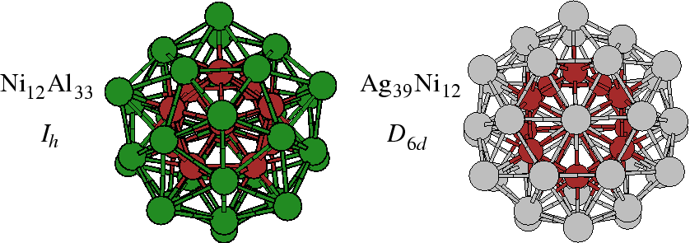

Meeting Fees
Fees include general and secretariat costs, participation in the scientific sessions, coffee-breaks, book of abstracts and other meeting materials.
 | Early
Participant | 550 EUR | 650 EUR
Student | 150 EUR | 200 EUR
Accompanying Person | 150 EUR | 200 EUR
Russian Participant¹ | 2500 rub | 3000 rub
Russian student² | 500 rub | 750 rub
¹ Registration fees for Russian participants reduced thanks to the sponsorship of the Russian Academy of Sciences and the Russian Foundation for Basic Research.
² Students are required to enclose a copy of their student card (or a letter from their head of the department for post-graduate students).

Payment in rubles (For Russian participants only)

ИНН 7801019101 КПП 780101001 УФК по г. Санкт-Петербургу
(ОФК 02, ИХС РАН, л/сч 03721147870)
Счет № 40503 810 60000 100 0001 БИК 044030001
Банк получателя: ГРКЦ ГУ Банка России по г. Санкт - Петербургу
г. Санкт – Петербург

В назначении платежа указать:

- П.5. Разрешения №267 от 28.11.2006 г.
- Код дохода 31930399010010000180
- ФИО участника конференции
- Оргвзнос ISN-2009

BANQUET
Dear Colleagues!
We’d like to invite you to participate at the EVENING PARTY, which will take place in
the new restaurant «Casa del Mясо», situated at the Saint-Petersburg central part.
Here we are able to have a good time, to enjoy a friendly climate and
to taste European cuisine
Cost is 50 €
ACCOMMODATION

 | 
  S-Continental Company
  Official tour operator of the Conference
  Information and Structure
  in the Nanoworld
  Saint Petersburg, Russia
  July 01-03 2009
SPECIAL OFFER FOR ACCOMMODATION
For exhibitors and visitors of the Conference
Company name_____________________________ Contact person___________________________________
Address__________________________________________________________________________________
Zip____________________________________ Phone / fax_________________________________________

Hotel name ……………………………………….
Check-in date |  | Check-out date |  | Single rooms Names
Check-in date |  | Check-out date |  | Double rooms Names
SPECIAL OFFER FOR ACCOMMODATION
HOTEL |  |  |  |  |  | Price per room per night in €
 |  |  |  |  |  | Single | Double
Hotels, located on Vasilievsky Island, not far from the Institute of Silicate Chemistry RAS
«Rinaldi» Vasilyevskiy 3* www.rinaldi.ru  Address: Vasilyevskiy island, Malyi pr. (10-15 minutes to Institute of Silicate Chemistry RAS) |  |  |  |  |  | 76 € | 90 €
«Marco Polo» 4* www.mpolo-spb.ru  Metro station “Vasileostrovskaya”  Address: 48/27, 12 line (10-15 minutes to Institute of Silicate Chemistry RAS) |  |  |  |  |  | 153 € | 159 €
Courtyard by MARRIOTT 5* www.marriott.com  Metro station “Vasileostrovskaya”  Address: Vasilyevskiy isl., 2 liniya 61/30 (10-15 minutes to Institute of Silicate Chemistry RAS) |  |  |  |  |  | 192 € | 206 €
Hotels, located in the city center (on Nevsky prospect)
“Hotel Vera” 3* www.hotelvera.ru  Metro station “Vosstaniya sq.” |  |  |  |  |  | From 66 € | From 100 €
Address: 25/16, Suvorovsky pr. (35-40 minutes to Institute of Silicate Chemistry RAS)
«Rinaldi» St. Isaac’s square 3* www.rinaldi.ru  Address: Vasilyevskiy island, Malyi pr. (20-25 minutes to Institute of Silicate Chemistry RAS) |  |  |  |  |  | 76 € | 90 €
“Anabel” 3*www.anabel.ru  Metro station “Vosstaniya sq.” Address: Nevsky pr, 88  (35-40 minutes to Institute of Silicate Chemistry RAS) |  |  |  |  |  | From 94 € | From 105 €
* Prices are subject to change (in case of official ROE changes)
We are ready to offer other hotels upon your individual request
Common check-in time: 14:00; check-out time: 12:00
Visa support: free for S-Continental clients
Transfer service:
Airport-hotel: from 50 Furo railway station – hotel: from 50 Furo
Hotel-airport: from 50 Furo Hotel – railway station: from 50 Furo
Sightseeing program is available on request
For further information, please do not hesitate to contact us:
Tel. +7 812 717 66 88, 717 19 44 Fax: +7 812 332 00 91
E-mail: info@scontinental.com web: www.scontinental.com
Director: Maria Tsurikova, manager: Natalia Polushkina
TRADITIONALLY HIGH QUALITY OF SERVICES SINCE 1997

The organizers have foreseen also the accommodation in low-rate rooms in hostel-type hotels “Nauka” ― departmental hotels
of the Russian Academy of Sciences:

 | “Nauka”, Bldg. 1:  price list (day (and night))*:  single-room – 800-900 rubles  double-room – 1100-1200 rubles  * for room | Millionnaya street, 27  ( nearest metro - station “Nevskii prospekt”)
 | “Nauka”, Bldg. 2:  price list (day (and night))*:  single-room – 1400 rubles  double-room – 680 – 1300 rubles  three-local hotel accommodation –  1050 – 1650 rubles  * for room | Prospekt Engelsa, 65  (nearest metro - station “Udelnaya”)
“Nauka”, Bldg. 3 (campus RAS)  price list (day (and night))*:  double-room – 800 rubles  five-local hotel accommodation - 1050 – 1200 rubles  * for room |  | Prospekt Morisa Toreza, 37  (nearest metro - “Ploshchad Muzhestva”)

Contact
Institute of Silicate Chemistry RAS,
Nab. Makarova, 2
Saint-Petersburg, 199034, Russia
E-mail: nano2009@isc.nw.ru
URL: http://www.isc.nw.ru/Eng/Conferences.htm

Transportation

1. Airport “Pulkovo-1” ⇒ bus 39 (mini-van K-39, K-39A) ⇒ Metro “Moskovskaya” ⇒
Metro “Nevskiy Prospekt” ⇒ trolleybus 10, 7, 11, bus 7, 24, 191
Metro “Sportivnaya” ⇒ trolleybus 7, bus 10, 191
and any mini-van to the “Birzhevaya Ploshchad” (Vasilyevskiy Island Arrow).
2. Airport “Pulkovo-2” (International) ⇒ mini-van K-39 ⇒ Metro “Moskovskaya” ⇒ and so forth.
3. Railway Station “Moskovskiy Voksal” ⇒ Metro “Ploshchad Vosstaniya” ⇒ and so forth.

Financial support, Sponsors

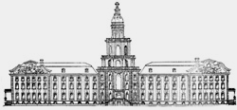
Russian Academy of Sciences
www.ras.ru

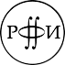
Russian Foundation for Basic Research
www.rfbr.ru



www.alfa-jewell.com

